**Significance of the work**

The intention of this work was to bring a new technology to rapidly edit the SARS-CoV-2 genome in vivo by using “eukaryotic multiplex automated genome engineering” (eMAGE). This synthetic biology approach, invented in the laboratory of co-PI Farren Isaacs, enables precise, multi-site (i.e., multiplex) gene modifications at single bp resolution, with high efficiency and without unintended mutagenic changes, at targeted genomic loci in Saccharomyces cerevisiae. This is especially valuable for work with RNA viral genomes, which encode proteases and viroporins that are often highly toxic to mammalian cells. Furthermore, the large size of the yeast artificial chromosomes that carry the viral genomes facilitates work with large RNA viruses such as SARS-CoV-2. This method holds great promise for viral RNA research. We had planned to install bursts of mutations into fragment-binding sites in SARS-CoV-2 proteins Mpro, N and Mac1, targets of interest to ASAP. In addition, full-length clones of EV-D68 and EV-A71 genomes were to be prepared and utilized for Targeted Deep Mutational Scanning at fragment-binding sites of interest to ASAP.

Unfortunately, most of the planned contributions of this Developmental Project have not been realized. Principal InvestigatorI Brett Lindenbach became gravely ill in the past year and ultimately succumbed to his disease on December 16, 2023.

**Significant project-generated resources**

The SARS-CoV-2 virus that contains a mutation in the active site of Mac1 has been supplied to the Antiviral Core and provides a valuable negative control for campaigns to inhibit Mac1 activity with antiviral compounds.

Genetic resources, including full-length cDNAs for SARS-CoV-2 and target enteroviruses within yeast artificial chromosome vectors, will be available from the Yale laboratories of Farren Isaacs and Craig Wilen.

A manuscript describing the application of eMAGE technology to the RNA virology field is in preparation and will acknowledge the funding by NIAID and ASAP.

**A. Specific Aims for the MP/DRP**

The Specific Aims have been modified from the original, competing application. Due to the demise of PI Brett Lindenbach and the closure of his laboratory at Yale University School of Medicine, this research will not be continued.

**B. Studies and Results**

Working together, the laboratories of Drs. Brett Lindenbach and Farren Isaacs developed powerful multi-site (“multiplex”) techniques to edit the approximately 30-kb SARS-CoV-2 cDNA cloned within the stable genetic environment of the yeast artificial chromosome (YAC). As shown in Figure 1, this technique was used to mutagenize the active site of each enzymatic activity in SARS-CoV-2 (Fig. 1A) in the context of an RNA replicon in yeast. Each mutation was subsequently tested for replicon function in cultured cells. Not surprisingly, mutations in several of known crucial functions, such as PLpro, Mpro, nsp13 helicase, nsp12 RdRp and nsp14 methyltransferase, abrogated replication of the replicon RNA (Fig. 1B). However, other mutations in conserved active sites, including that in nsp3 (Mac1) did not affect replicon activity. This lack of a tissue-culture phenotype Mac1-deficient virus has plagued the development of antivirals directed at this activity. **In fact, the nsp3 ADRP mutant shown in Figure 1 was provided to the Antiviral Core of ASAP as a control virus for inactive Mac 1**. The manuscript that includes the data in Figure 1 is in preparation and **will include an acknowledgement of ASAP funding.**

The goal of this Developmental Award was to apply eMAGE for the deep mutational scanning of residues of interest to ASAP in the Nucleocapsid protein and in the nsp13 helicase, and to identify residues in Mpro that conferred resistance to ASAP inhibitors. These priorities changed during the course of the work for several reasons. First, the effectiveness of phylogenetic analysis of SARS-CoV-2 sequences accomplished by Jessie Bloom's laboratory has made deep mutational scanning of SARS-CoV-2 proteins less crucial. Second, newly enacted biosafety regulations precluded the selection for compound-resistant variants in the context of SARS-CoV-2 and the method is much less robust in the replicon setting. To contribute to ASAP in another way, we have constructed yeast vectors that encode full-length EV-A71 and EV-D68 in yeast artificial chromosomes. These constructs reside in the Yale laboratories of Farren Isaacs and Craig Wilen.

​​

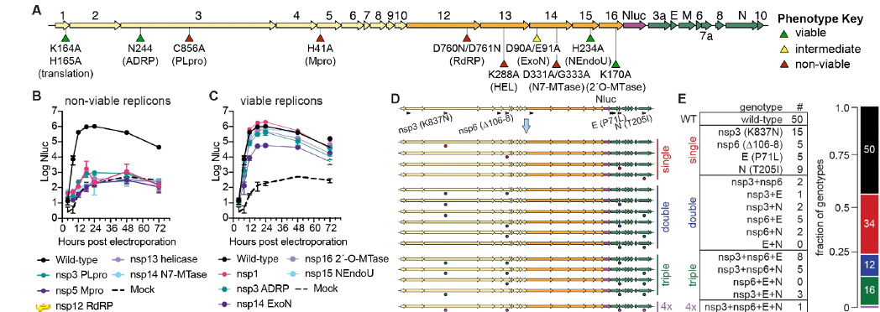

**Figure 1. Single and multiple eMAGE editing of SARS CoV-2 replicon RNA in yeast. A.** Schematic of non-infectious replicon RNA in yeast artificial chromosomes. A nanoluciferase (Nluc) reporter substitutes for the Spike protein. **B.** Non-viable phenotypes. Proteins listed are those whose active sites were mutated. **C.** Viable phenotypes. Mutation of the active sites of the proteins listed allowed RNA replication in cultured cells. **D.** Using multiple rounds of eMAGE to reconstruct non-spike variants of concern in the non-infectious replicon. **E.** Results of the quadraplexed eMAGE, showing that nearly all possible combinations of the variants of concern were obtained at high frequency in this non-infectious system.

**C. Significance**

The approach described in this proposal, to use the cDNAs of RNA viruses within yeast artificial chromosomes as platforms for directed deep mutational scanning and other genetic approaches, is highly suited to facilitate the research in many virology laboratories. It is anticipated that, with the publication of the manuscript currently in preparation that includes the date in Figure 1, other laboratories will utilize this technology.

**D. Plans**

This work has not continued due to the grave illness and untimely demise of Principle Investigator Brett Lindenbach. It is understood that a second year of funding will not be supplied and appreciate the support of NIAID and to ASAP for the first year of this work.